**User**

The following section allows users to include privileged users who are currently in an Active state at the Project level. Users also have the option to assign specific roles to each individual. By default, Full Access Roles are assigned to Super Admins and Admins.

**Navigation**

**Project Selection > Projects Tab > Users**

**The details of the user section**

**Add button** - By simply clicking the "Add" button, users can add new user privileges, and assign them suitable roles. The "Users" tab can be accessed from the Project menu section, where the Users List is displayed.

**Add User Pop-Up Details**

After clicking the "Add User" button, a pop-up window will appear with the details displayed in the image below.

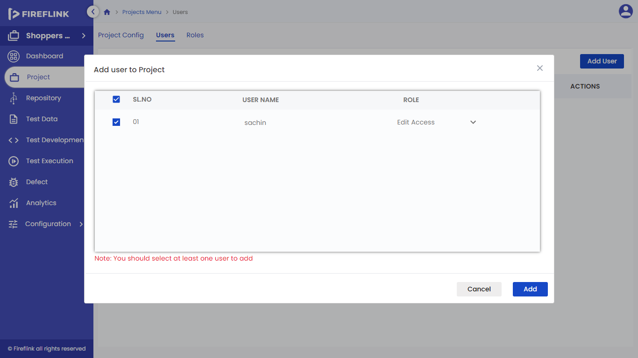

* **SL. NO:** This field is mandatory and is accompanied by a checkbox next to "Sl. No." When the checkbox is selected, it selects all names in the list. If one or more users are manually selected, the checkbox next to "Sl. No." is partially selected.
* **USER NAME:** This field displays the privileged users who are in an Active state that was created at the All-Projects level.
* **ROLE:** Roles created at All Projects level and Individual project levels are displayed in the Role dropdown.

**Procedure to Add a User**

* Press the "Add User" button
* The "Add User to Project" pop-up will appear.
* Choose the desired users to add and assign them a role.
* Click the "Add" button.
* The added user will appear in the User List.

**User Lists View**

The User List is a tabular representation that includes six columns. It serves as a dashboard, providing an overview of the added users' details, which are:

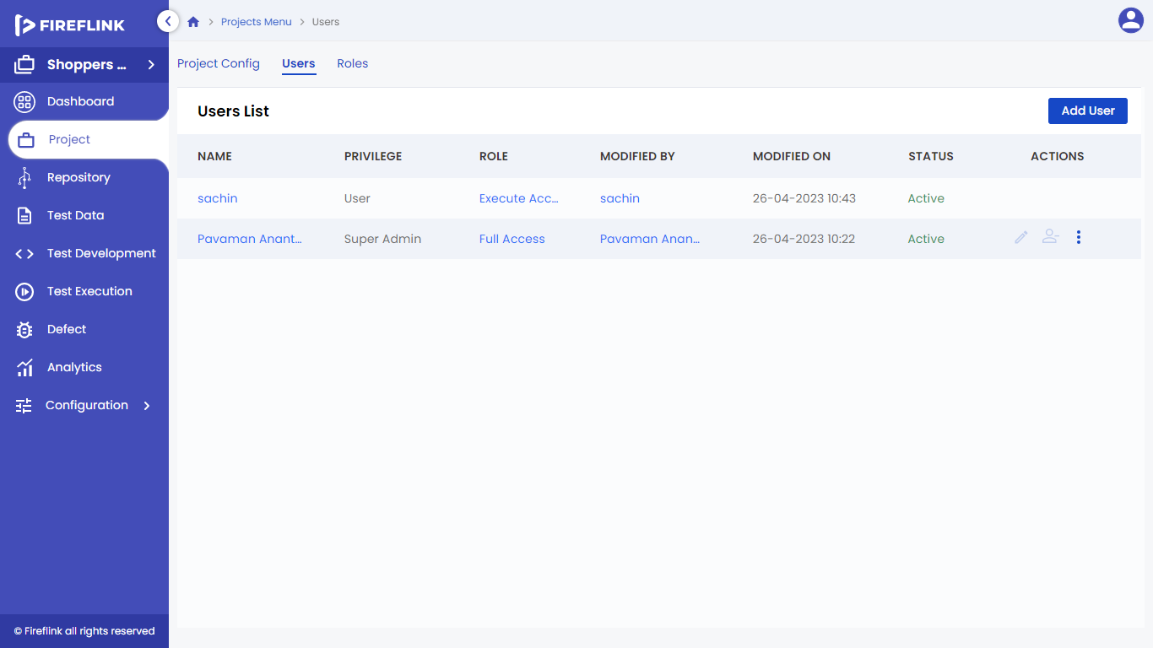

1. **Name:** Name of the user that is hyperlinked, which leads to the user details pop-up.
2. **Privilege:** This section displays the user's privilege, which can be either Super Admin, Admin, or User.
3. **Role**: Assigned role to the user is displayed here.
4. **Modified by:** The username of the user who has made modifications to the user details will be linked to their respective user profile.
5. **Modified On:** The Modified time of the User along with the date is recorded.
6. **Status**: This section shows the status of each user, which can be Pending Activation, Active, or Disabled state. If the user has not yet activated their account by clicking the generated link, their status remains in Pending Activation. Users also have the ability to change their status from Active to Disabled through the Edit User pop-up.
7. **Actions:** This field is not displayed automatically. The user has to hover the cursor over the particular user to see three options:

* **Edit**: Except for the email Id field, all fields here are editable. Users can modify it according to their requirements. (Note: Edit icon will be enabled only for User privileged users).
* **Remove:** Upon clicking this option, users can be removed.
* **More:** Users can utilize this functionality for 1 utility:

**Details**: User details are displayed

**Added User Details Pop-Up**

# 

The user details pop-up consists of all the data that is provided during the User creation. It contains the following details:

* **Name:** The name of the user will be displayed.
* **Email:** The entered email of the user will be displayed.
* **Privilege:** Privilege assigned to the user will be displayed.
* **Phone Number:** Phone number of the user will be displayed.
* **Status:** Whether the user is Active, Disabled, or Activation Pending will be displayed.
* **Created by:** Name of the user who has created the User will be displayed.
* **Created on:** Date, and time on which the user is created will be displayed.
* **Modified by:** Name of the user who has modified the User will be displayed.
* **Modified on:** Date, and time which the user is modified will be displayed.
* **Project Role Mapping:** This table is displayed, in which the user would be able to see the list of projects they are assigned.